Design Zero Trust Environment on Cloud (AWS Free Tier)

1. Zero Trust Principles
- Assume Breach: assume attackers can and will gain access to the environment.
- Verify Explicitly: continuously verify identity and security posture of every access request.
- Least Privilege Access: limit access to only what is necessary.
Implemented using AWS Free Tier services: IAM, S3, KMS, EC2, VPC, Security Groups, CloudWatch, SNS, EventBridge.

2. Overall Architecture
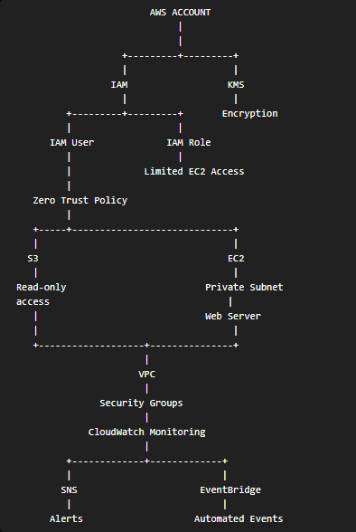

3. Identity Management (IAM)

3.1 Create IAM User with MFA
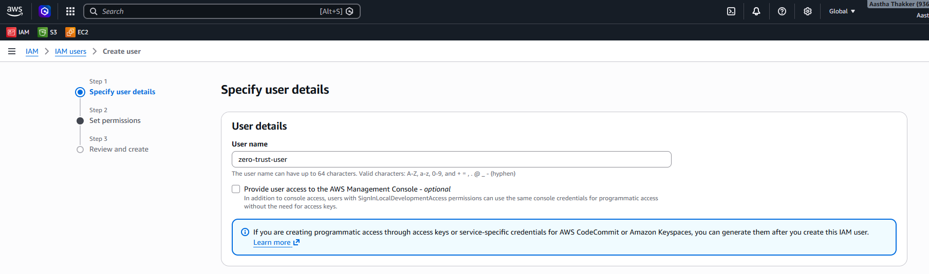
IAM user created.
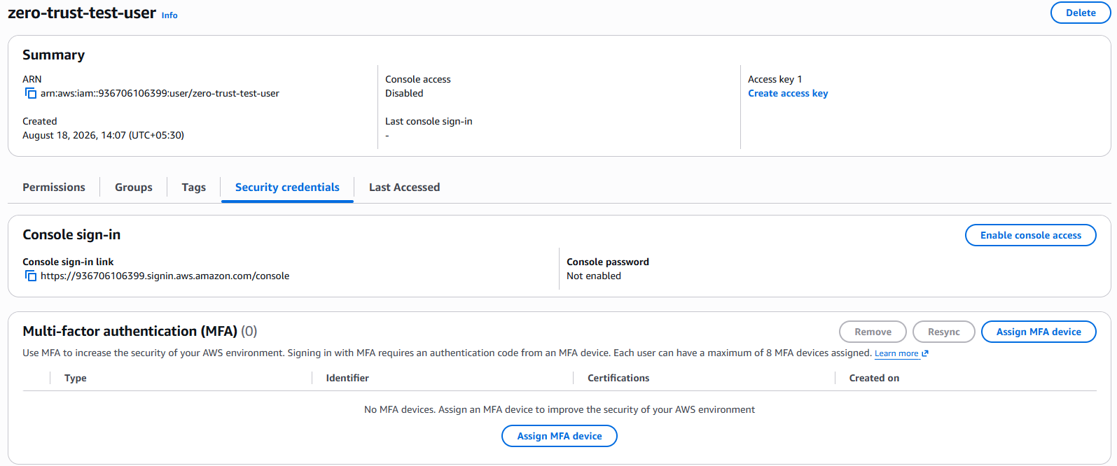
MFA device added to the user.
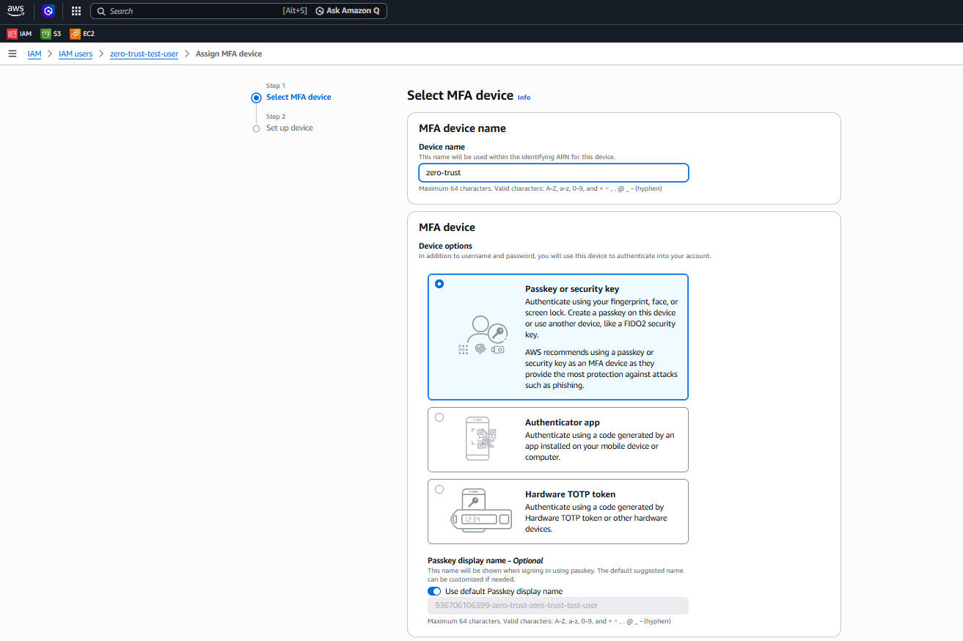
Passkey/MFA registration.
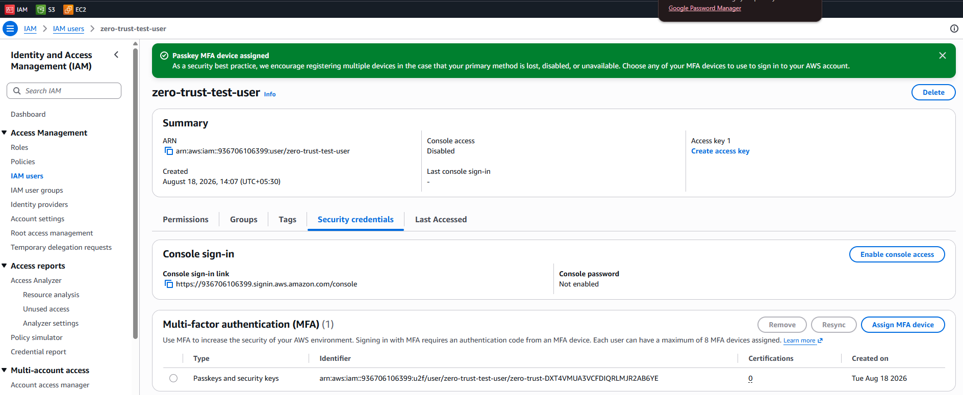
MFA setup completed.

3.2 Zero Trust IAM Policy (Least Privilege)
Policy grants: read-only objects from a specific S3 bucket, denies deletion of any S3 object/bucket, and read-only EC2 access.
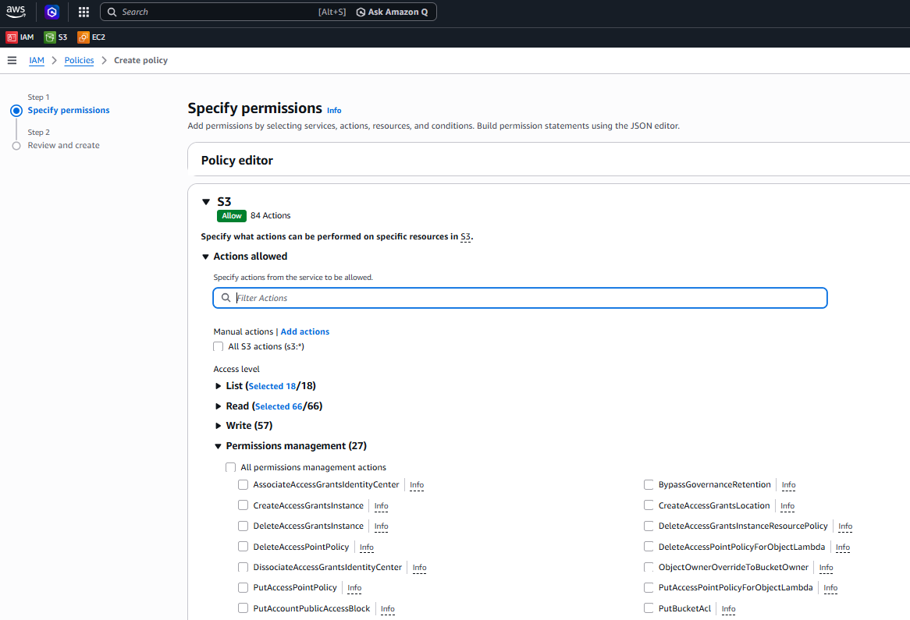
Creating the custom IAM policy.
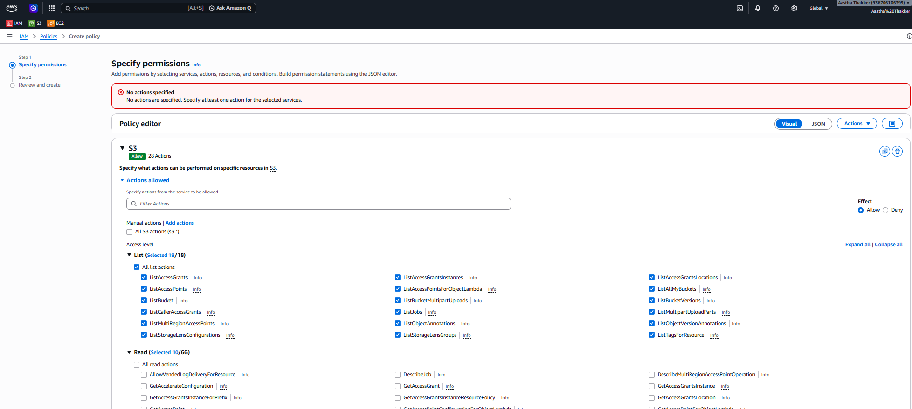
Policy configuration.
Custom JSON policy:
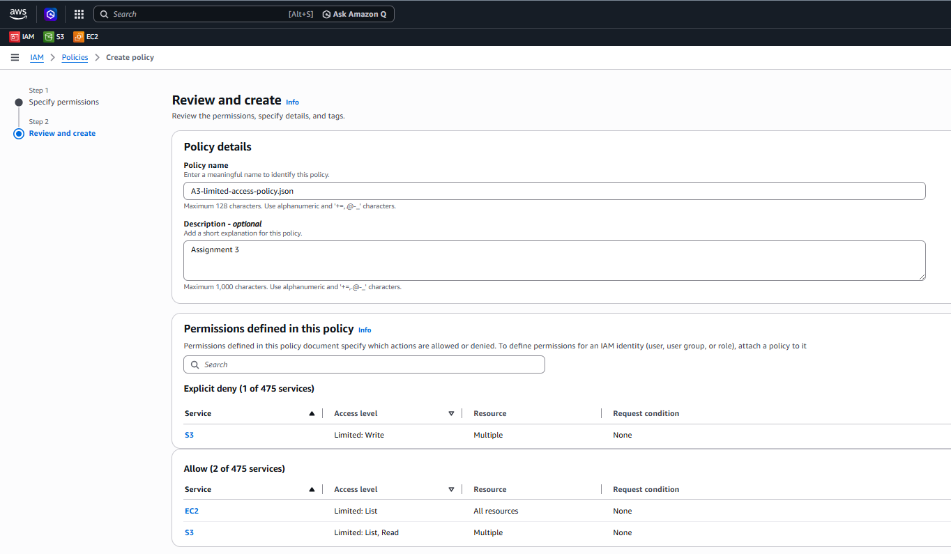
JSON policy document (S3 read-only, deny delete, EC2 read-only).
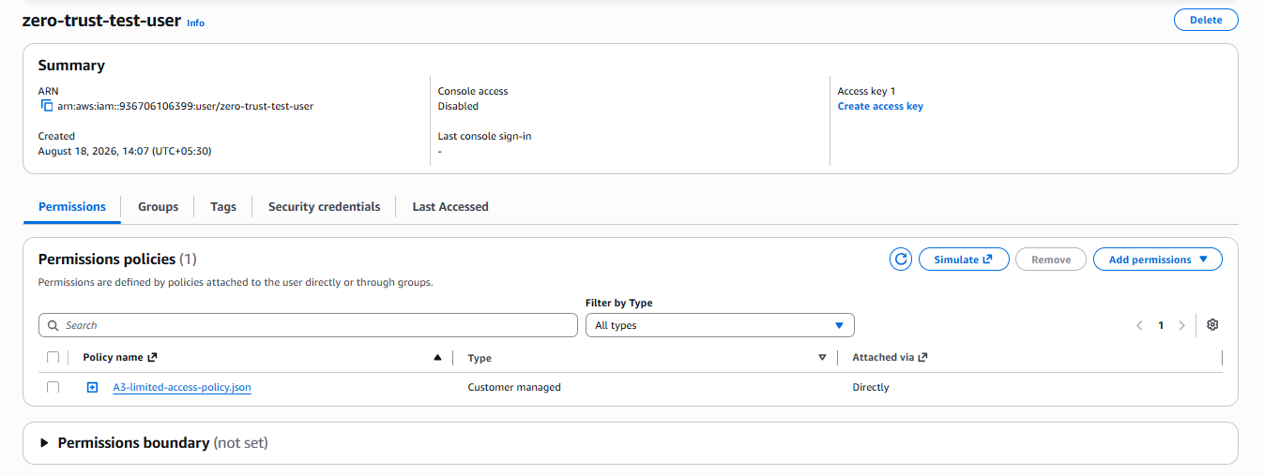
Custom policy attached to the IAM user (zero-trust-test-user).

3.3 Testing using policysim.aws.amazon.com
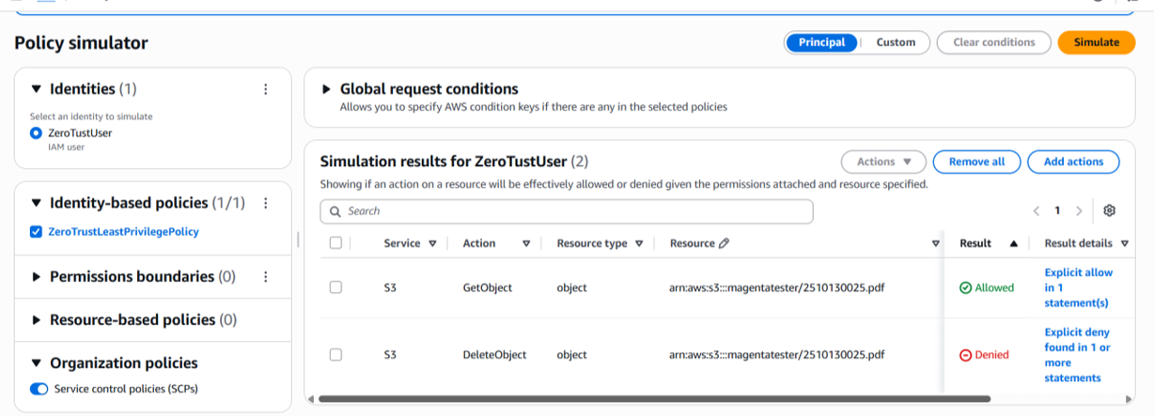
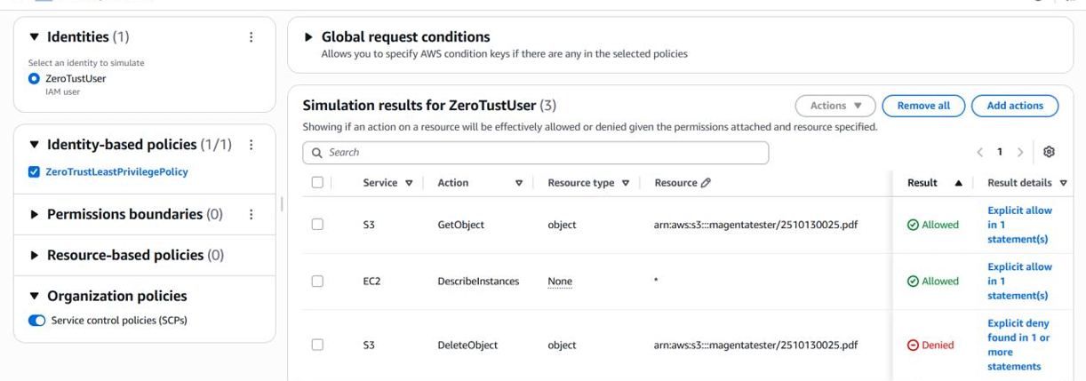

4. Create S3 Bucket
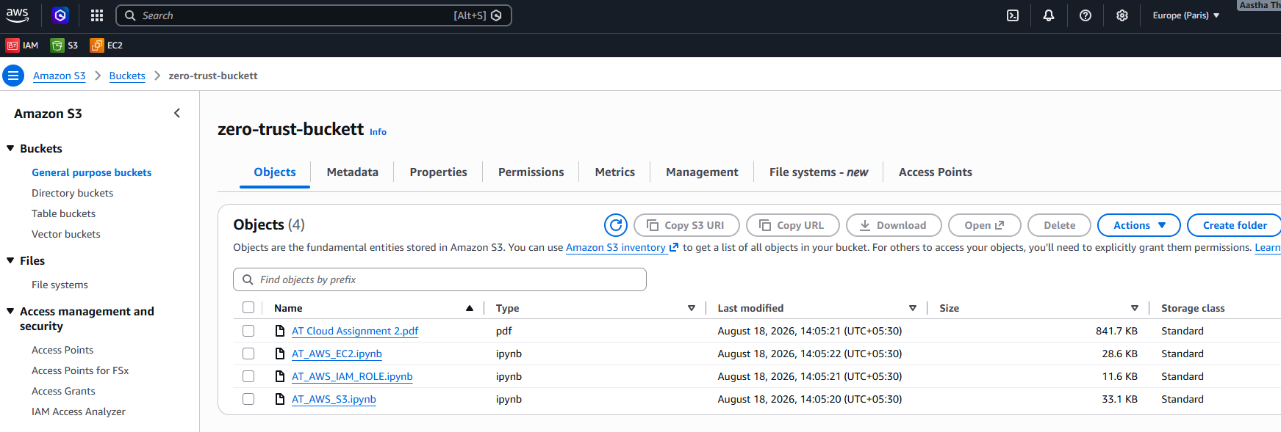
S3 bucket created.
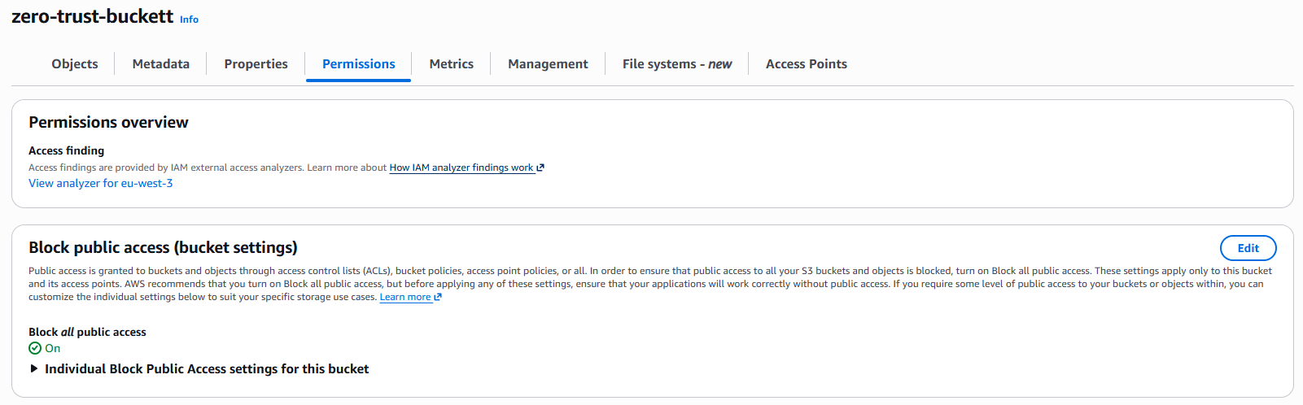
Block all public access enabled on the bucket.

5. Data Protection - KMS Encryption
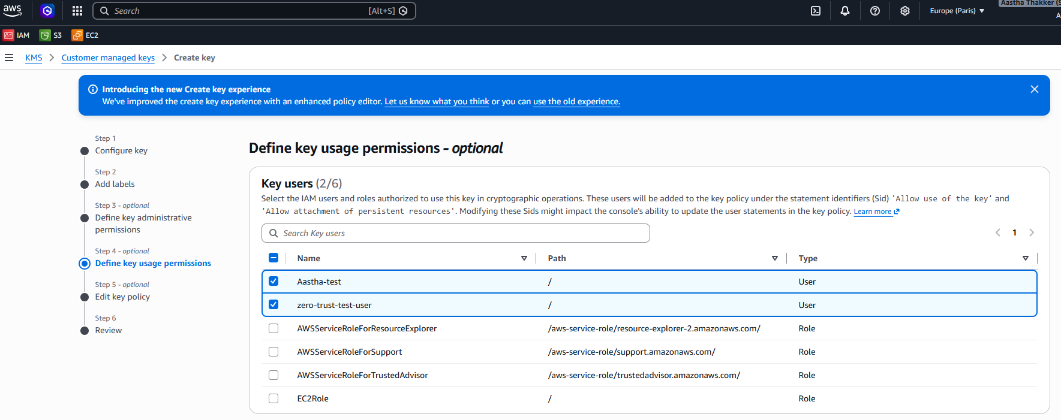
Creating a customer-managed KMS key and assigning key users.
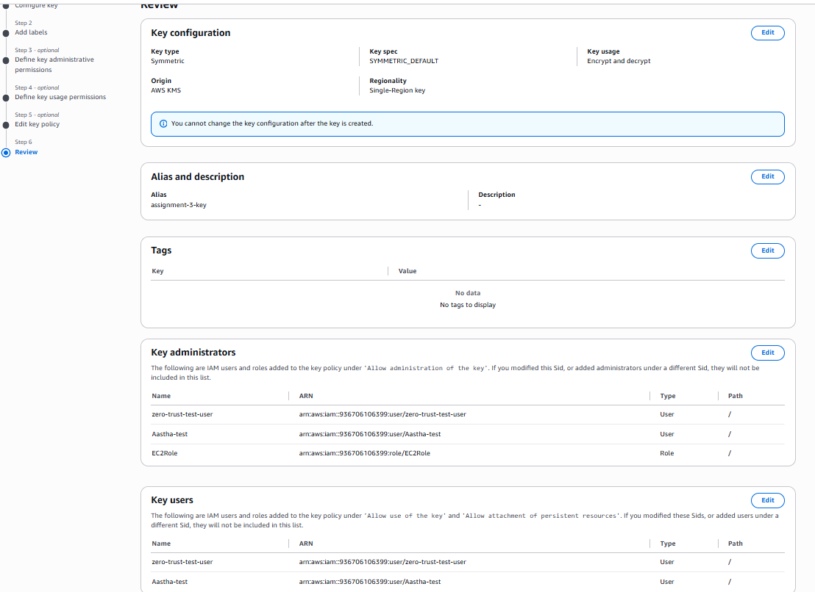
Reviewing key configuration, administrators, and key users.
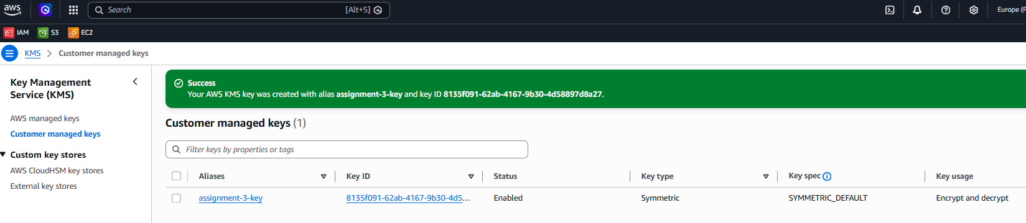
KMS key created successfully (alias: assignment-3-key).
Applying the KMS key to the S3 bucket for default encryption:
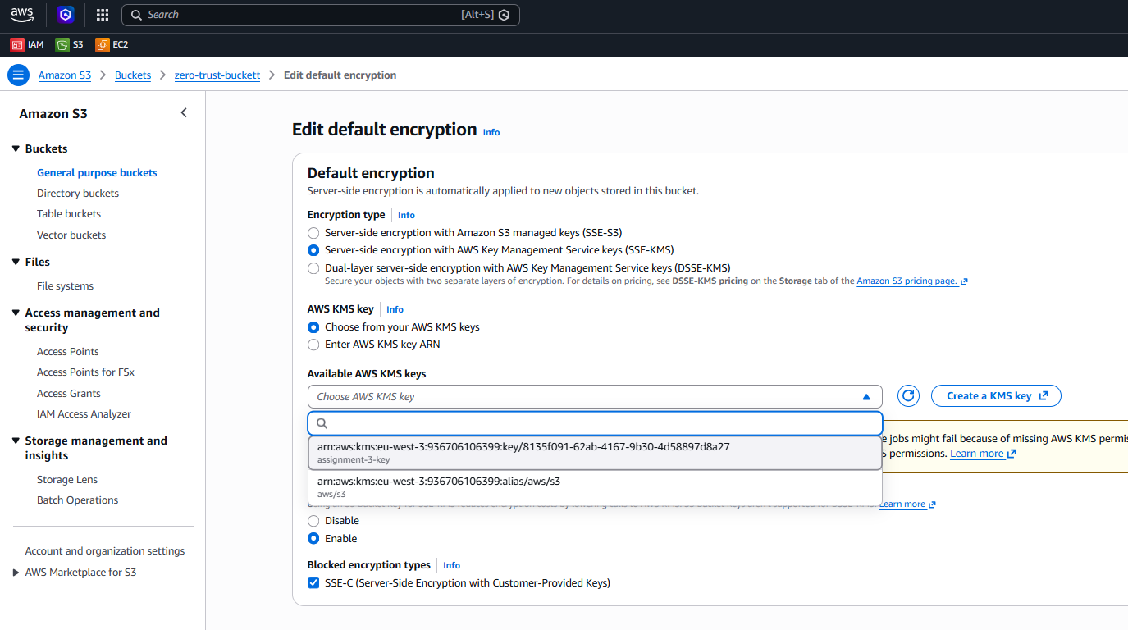
S3 bucket default encryption set to SSE-KMS using the created key.
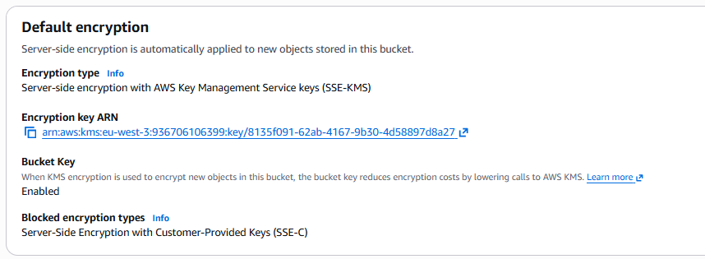
Encryption configuration confirmed on the bucket.

6. Infrastructure & Network Security - VPC
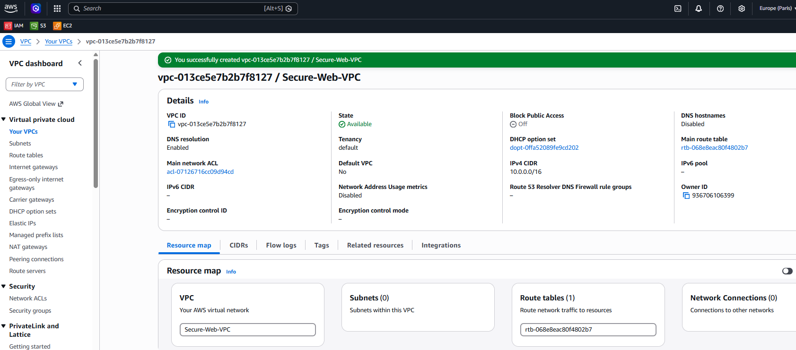
VPC created.
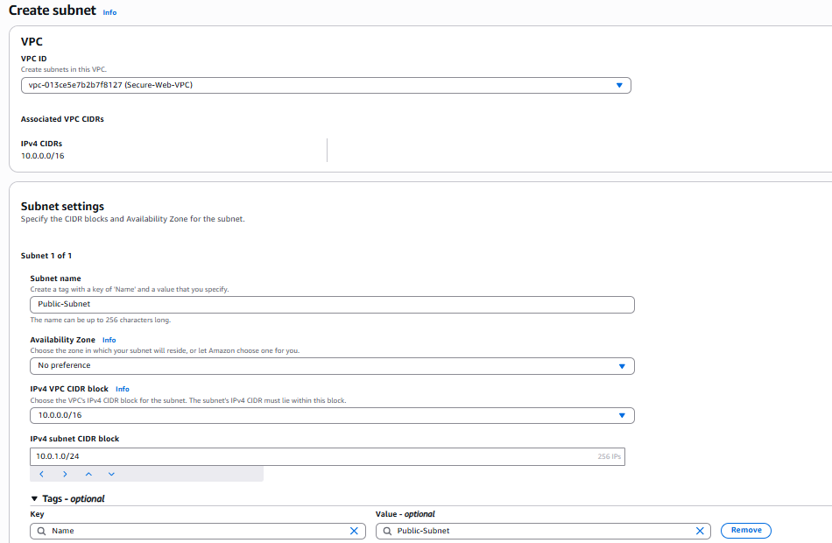
Public and private subnets configured.
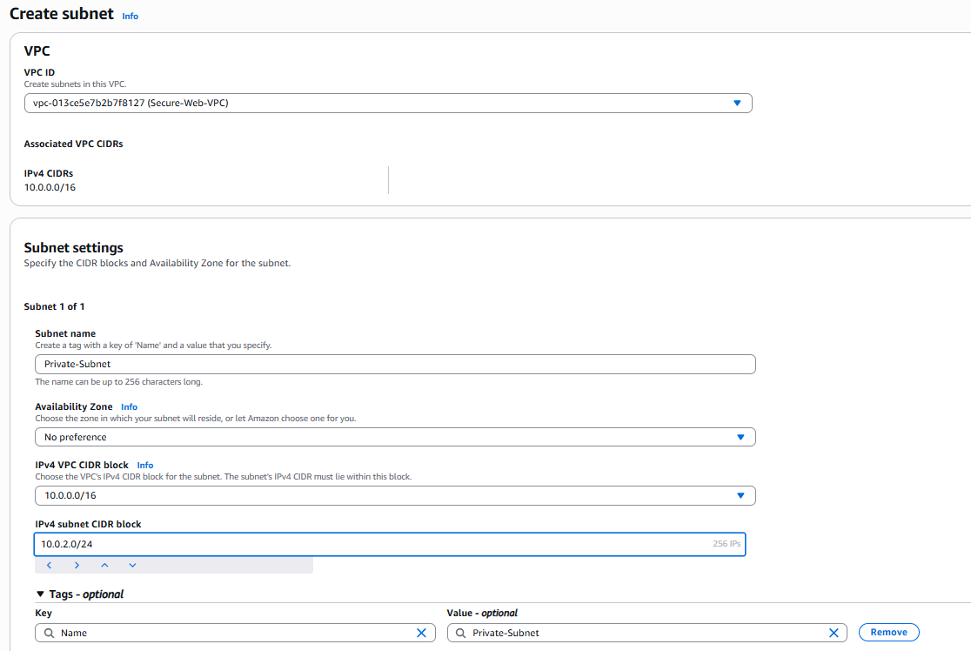
Subnet configuration details.
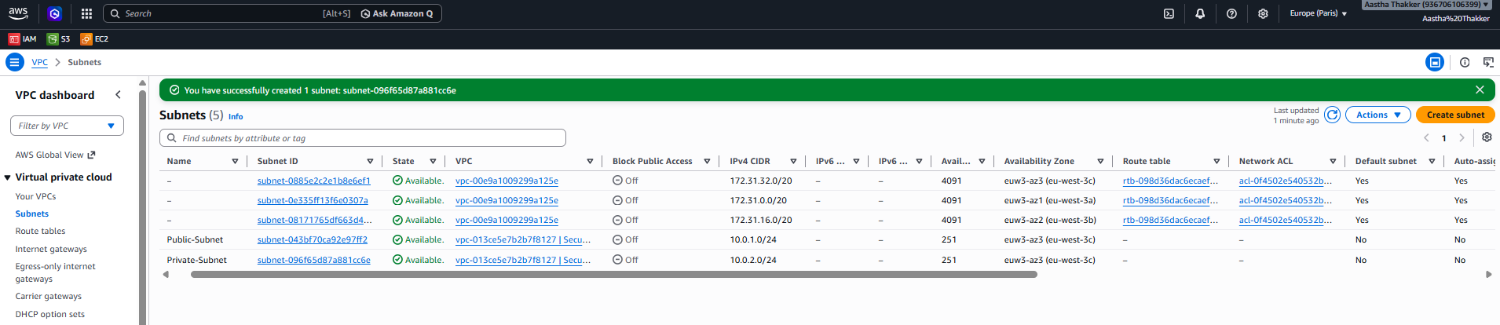
Internet Gateway created and attached to the VPC (provides internet connectivity to the public subnet).
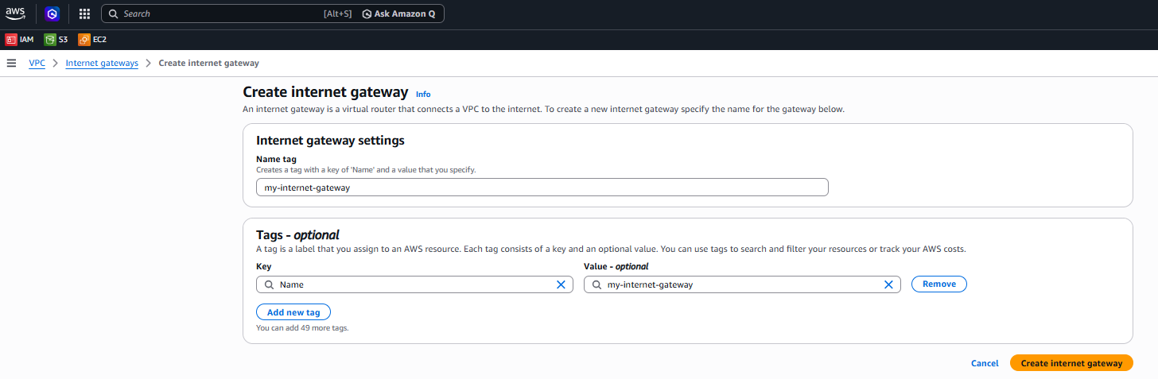
Internet Gateway attachment confirmed.
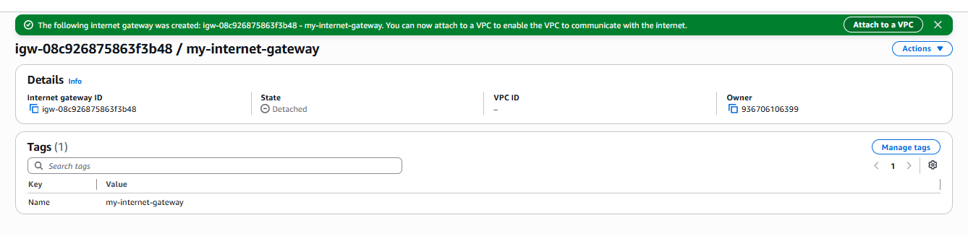
Route table setup.
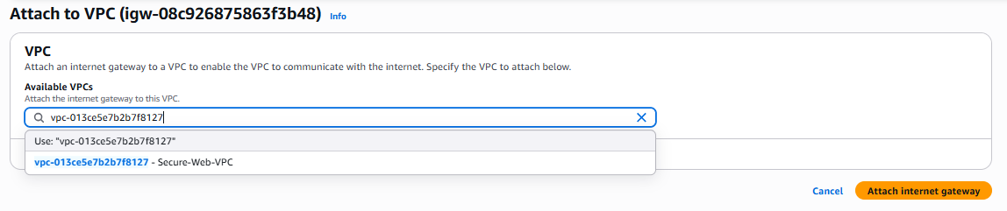
Route table associations.
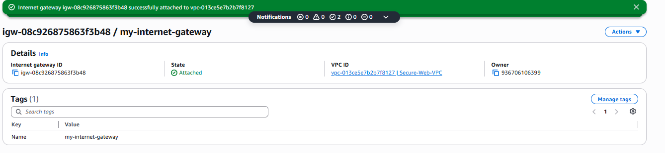
Route table rules (0.0.0.0/0 → Internet Gateway for public subnet).
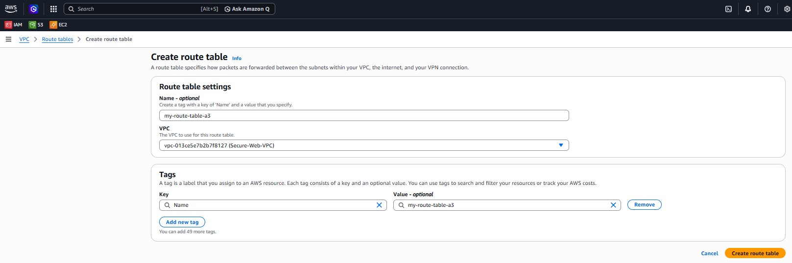
Route table created.
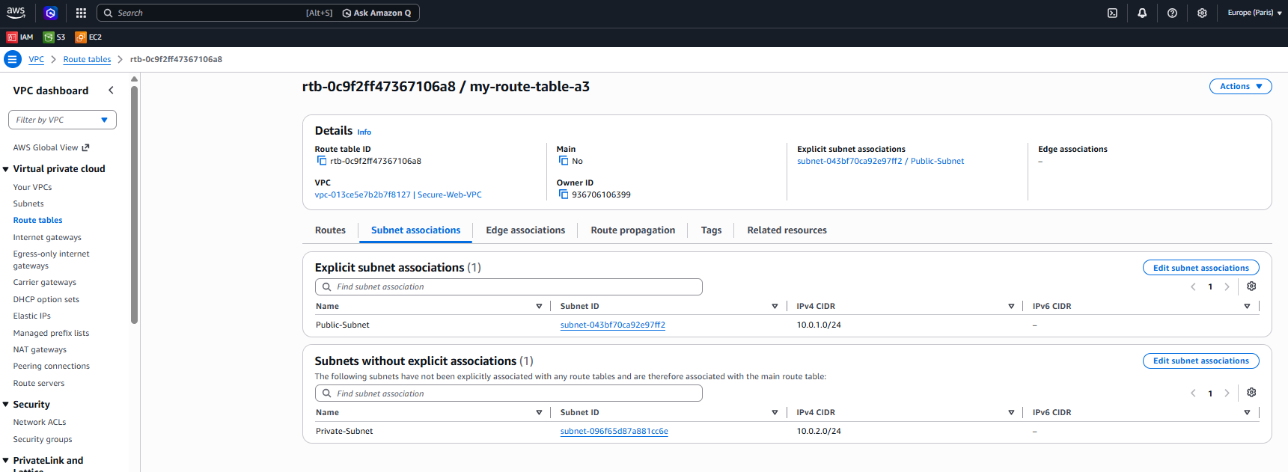
Route table review.

6.1 EC2 Web Server - Private Subnet
An EC2 instance was launched inside a private subnet as required.
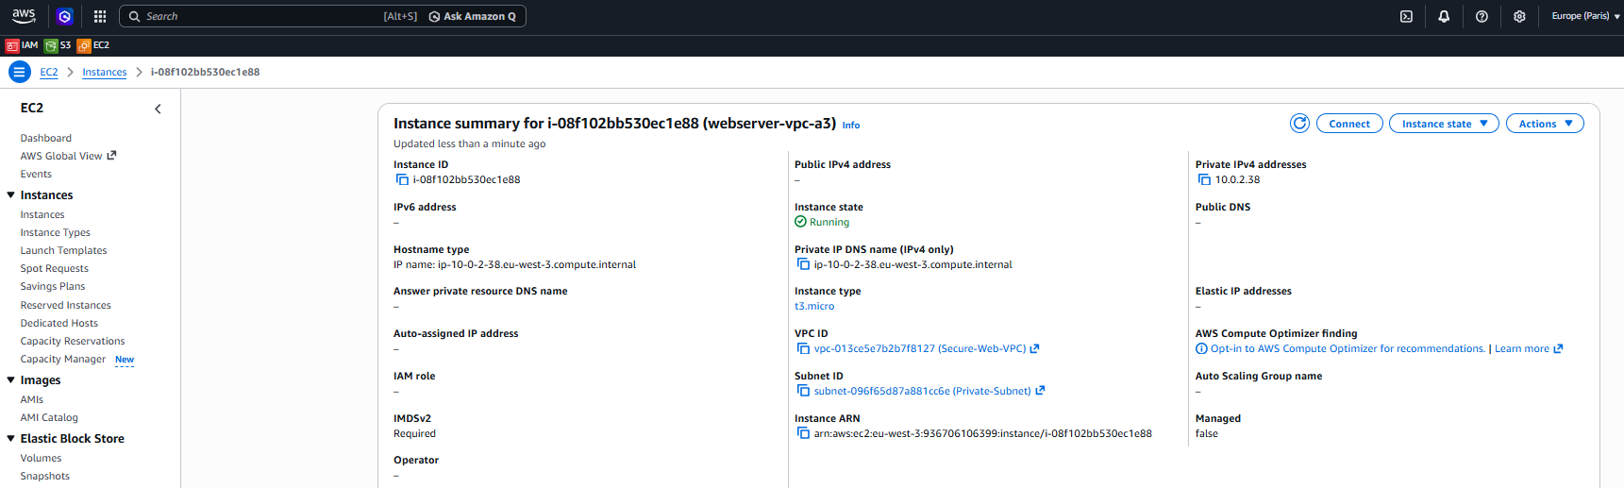
EC2 instance (webserver-vpc-a3) launched with Subnet ID = Private Subnet, no public IPv4 address.

6.2 Security Group - Firewall Rules
A security group (websecurity-a3) was configured as the instance firewall with the required inbound rules: HTTP (port 80) from any IPv4/IPv6 address, SSH (port 22) for shell login, and a custom TCP range 8000-9000 for the web server.
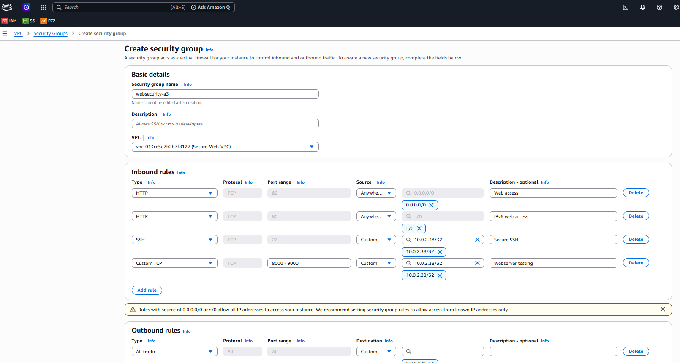
Security group inbound rules: HTTP (0.0.0.0/0 and ::/0), SSH (22), and Custom TCP (8000-9000).
A Security Group acts as a virtual firewall around the EC2 instance. SSH connectivity to the instance was tested from an authorized source IP as permitted by the rule.

6.3 EC2 Web Server - Public Subnet
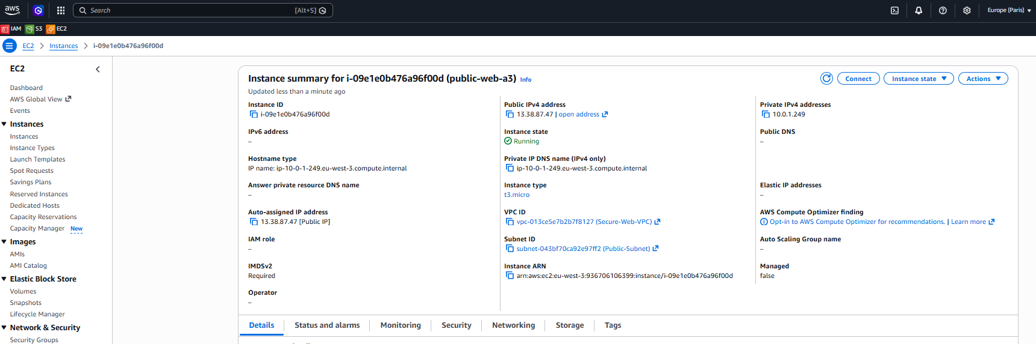
Public EC2 instance (public-web-a3) launched in the Public Subnet with a public IPv4 address, for hosting the static web server.
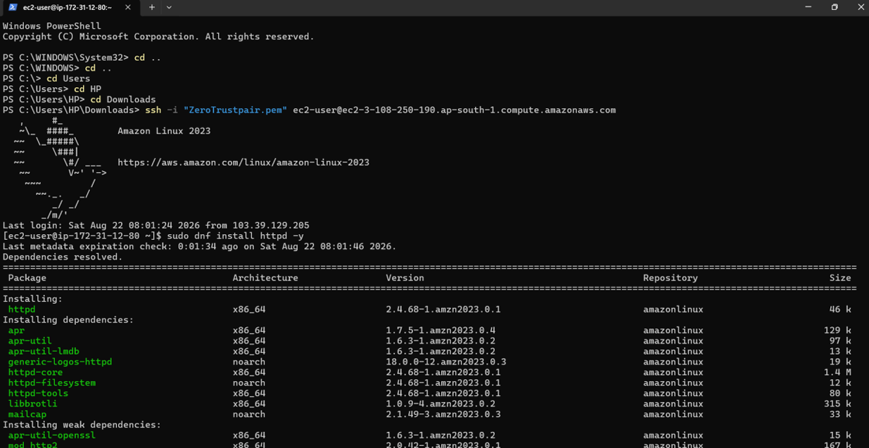
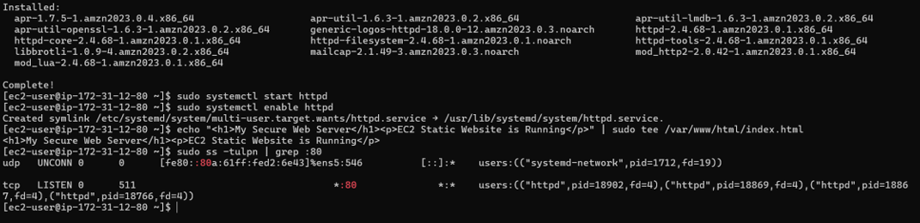
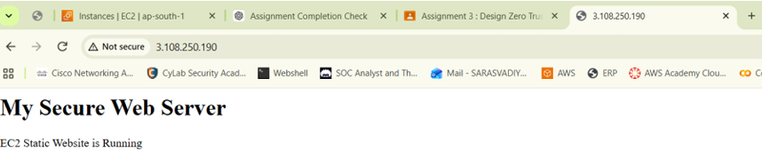

7. Monitoring and Visibility - CloudWatch
A CloudWatch dashboard was created to monitor CPU utilization, network traffic, and CPU credit balance/usage.
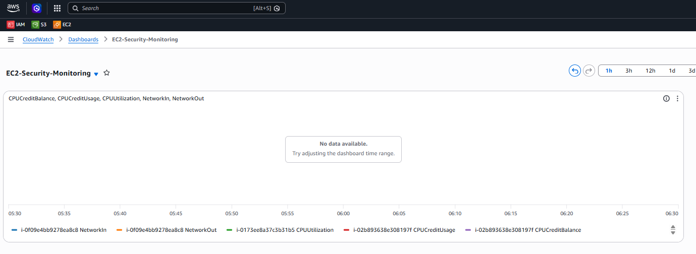
CloudWatch dashboard 'EC2-Security-Monitoring' tracking CPUUtilization, CPUCreditUsage, CPUCreditBalance, NetworkIn and NetworkOut.

7.1 SNS Topic & Subscription
An SNS topic was created to receive alarm and event notifications, with an email subscription.
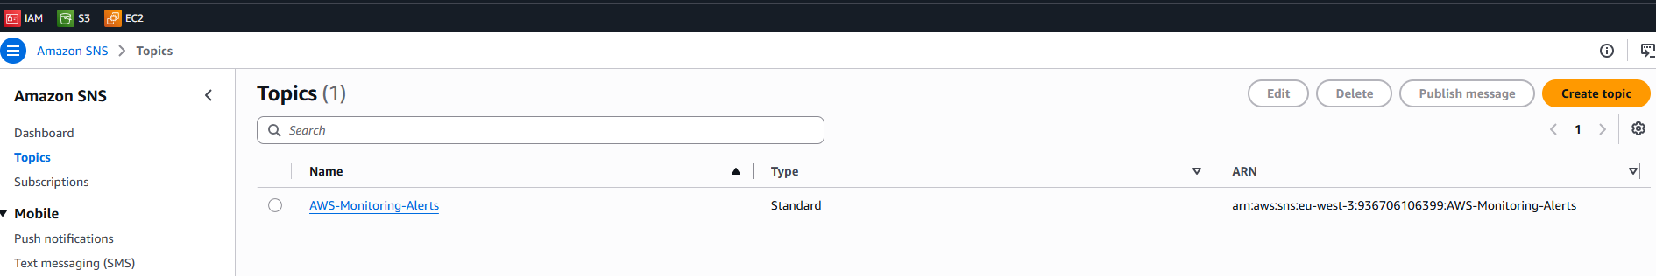
SNS topic 'AWS-Monitoring-Alerts' created.
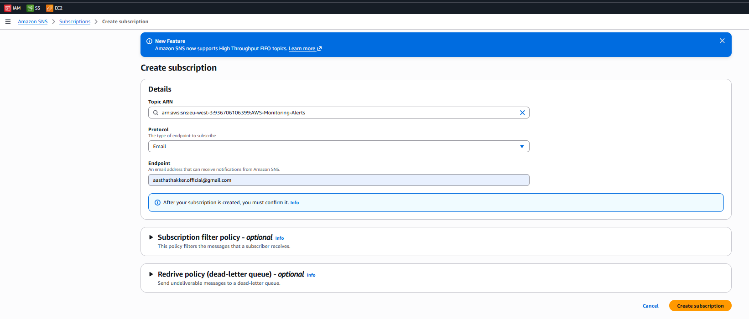
SNS subscription configuration.
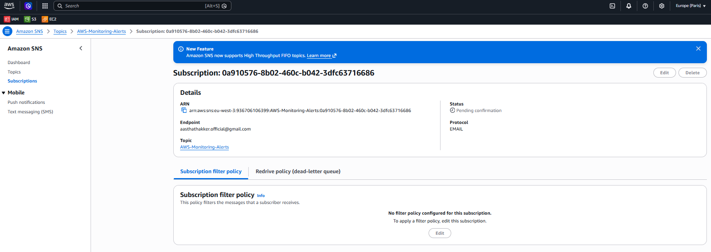
Email subscription added to the topic.
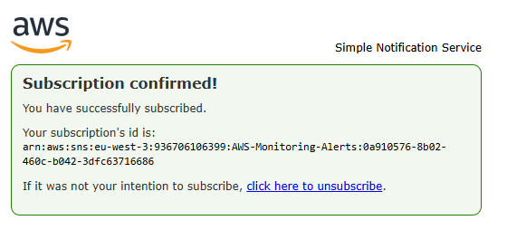
Subscription confirmed.
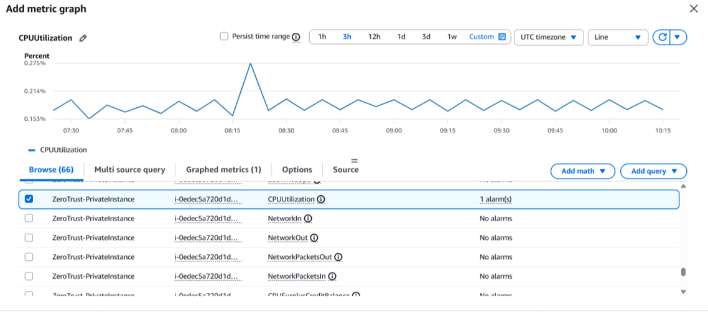

7.2 CloudWatch Alarm - CPU Utilization > 80%
CloudWatch → Alarms → Create alarm → EC2 → CPUUtilization → WebServer, with SNS notification action.
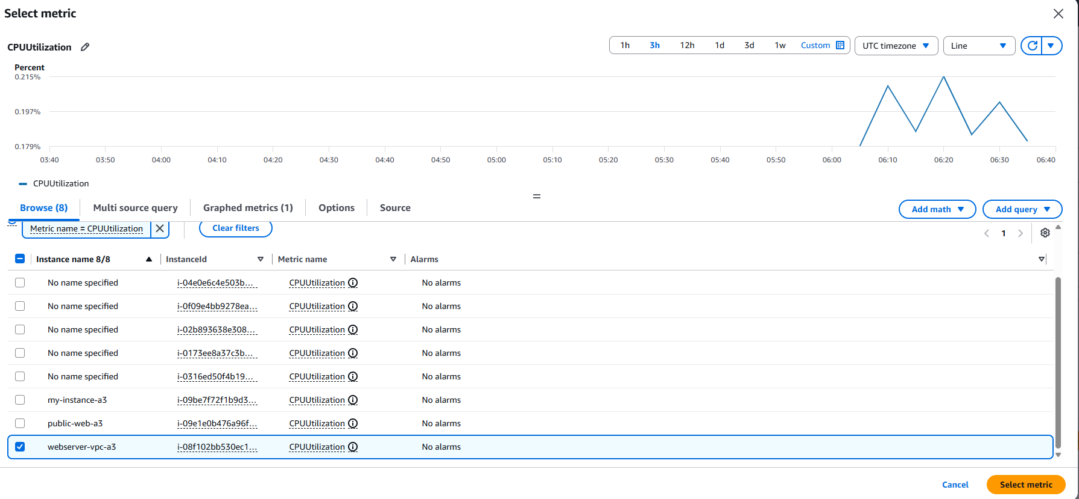
Selecting the CPUUtilization metric for the web server instance.
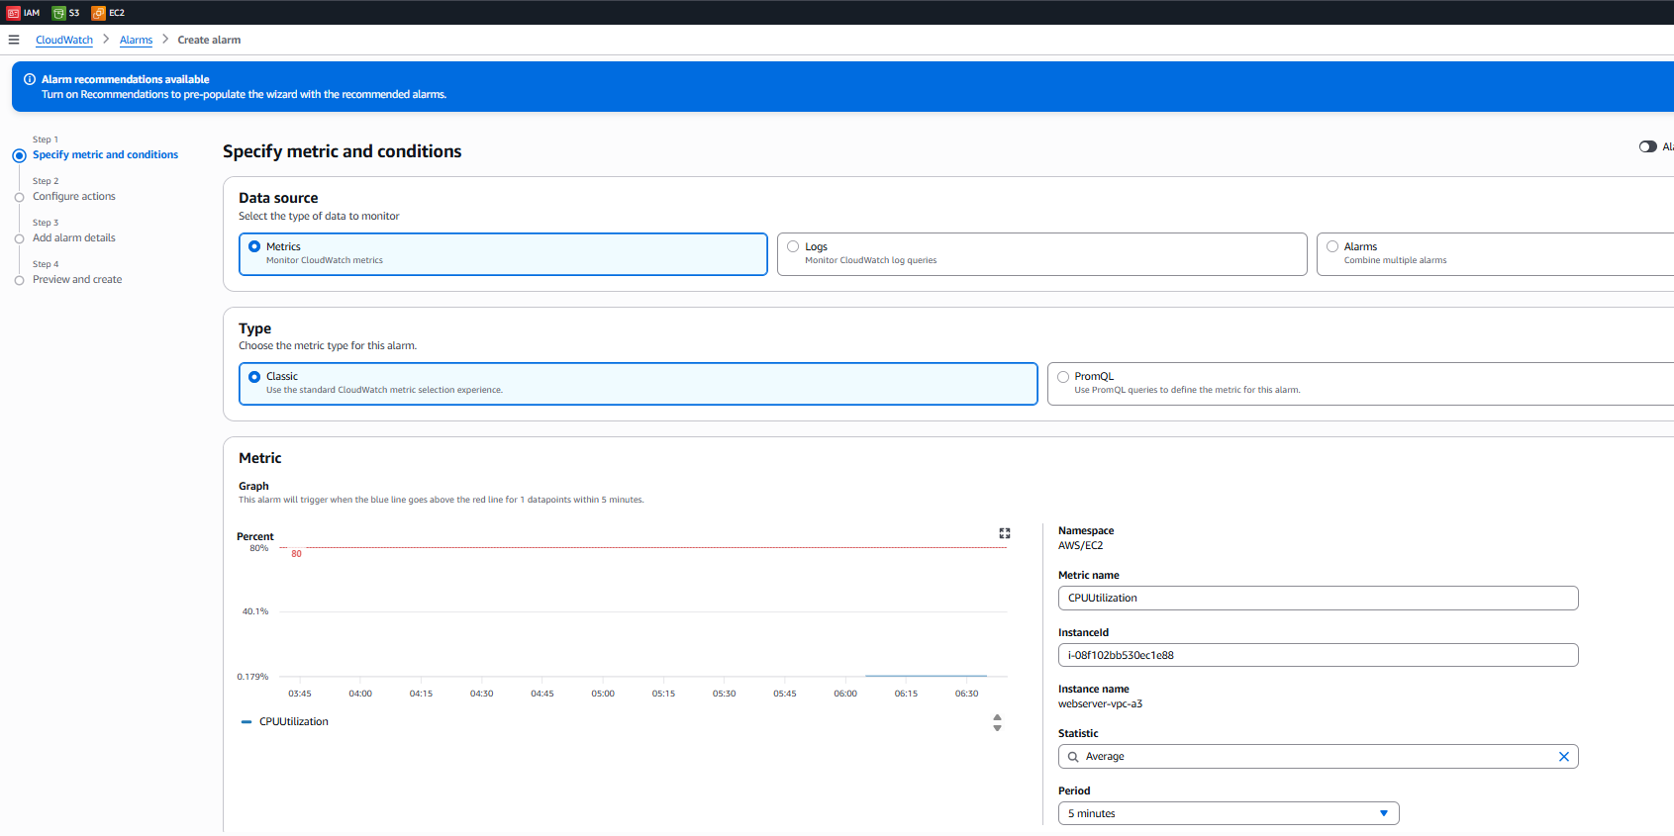
Setting the threshold condition (> 80%).
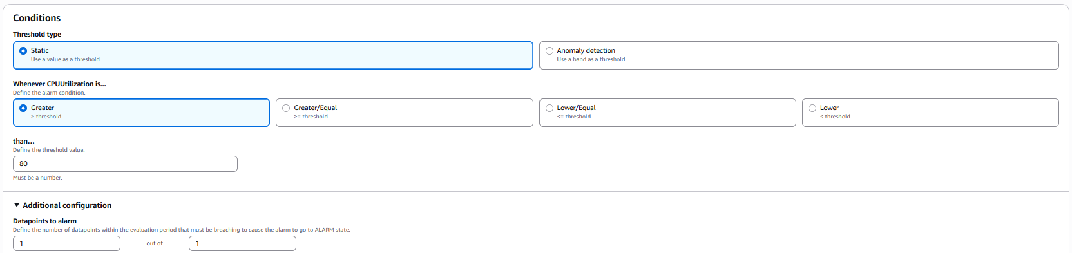
Configuring the SNS notification action for the alarm.
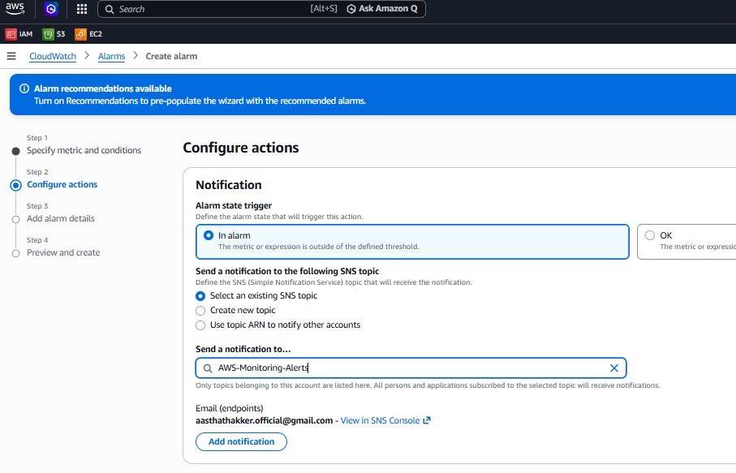
Alarm naming and description.
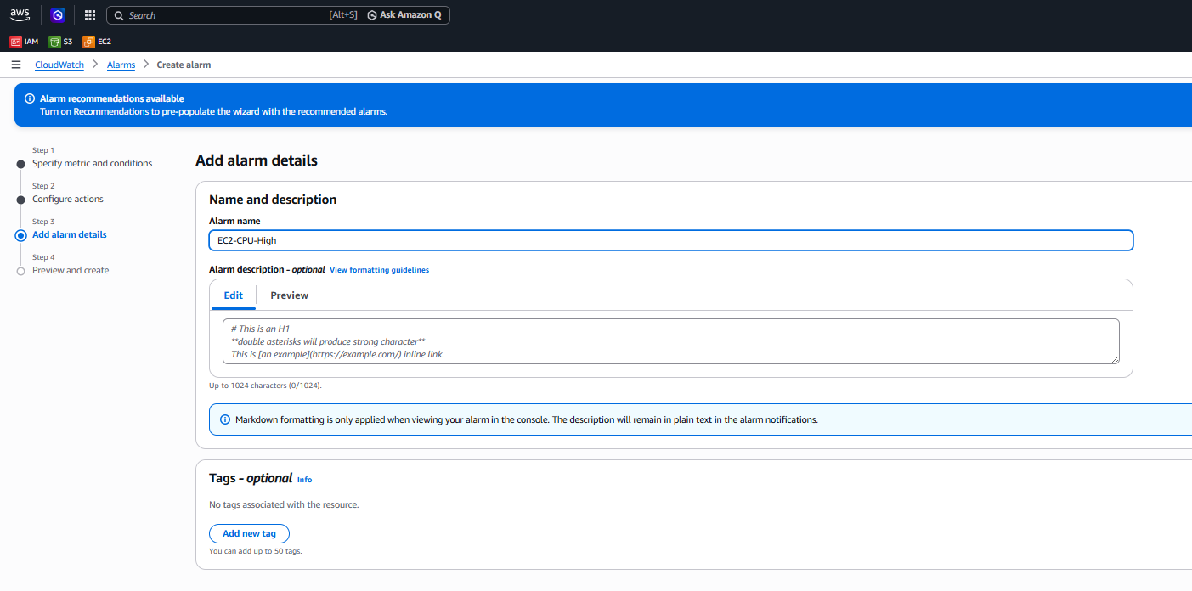
Alarm preview before creation.
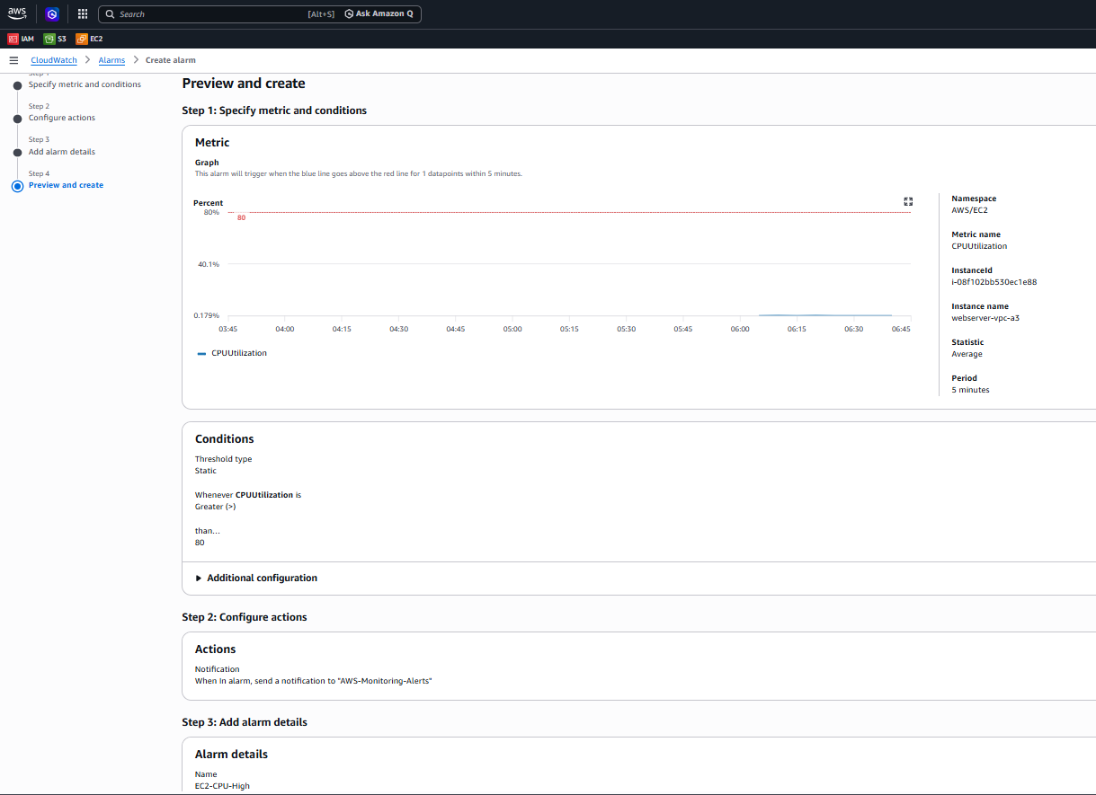
Alarm created and reviewed.
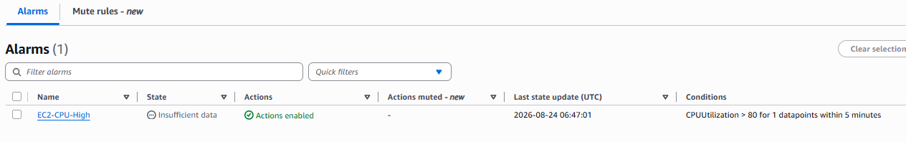
Alarm 'EC2-CPU-High' active with condition CPUUtilization > 80 for 1 datapoint within 5 minutes.

7.3 Billing Alarm - Cost > $200 / ₹15,000
Billing and Cost Management → Budgets → Create budget.
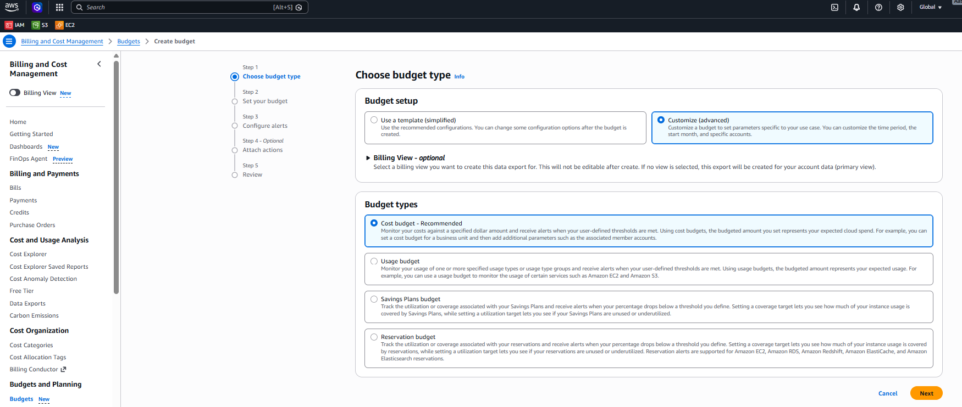
Creating a cost budget.
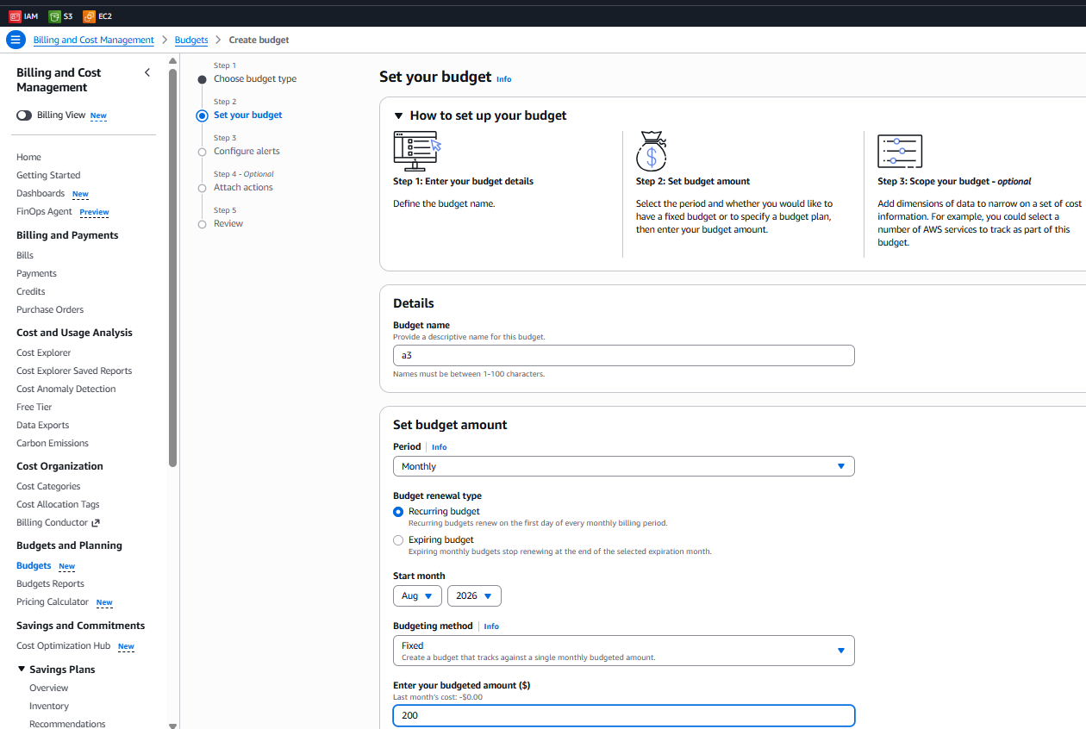
Setting the budget amount and period.
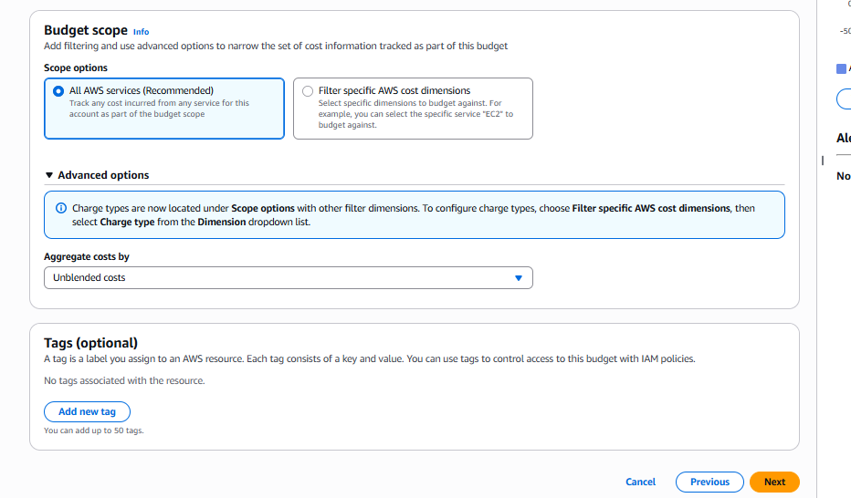
Configuring alert threshold and SNS notification for the budget.
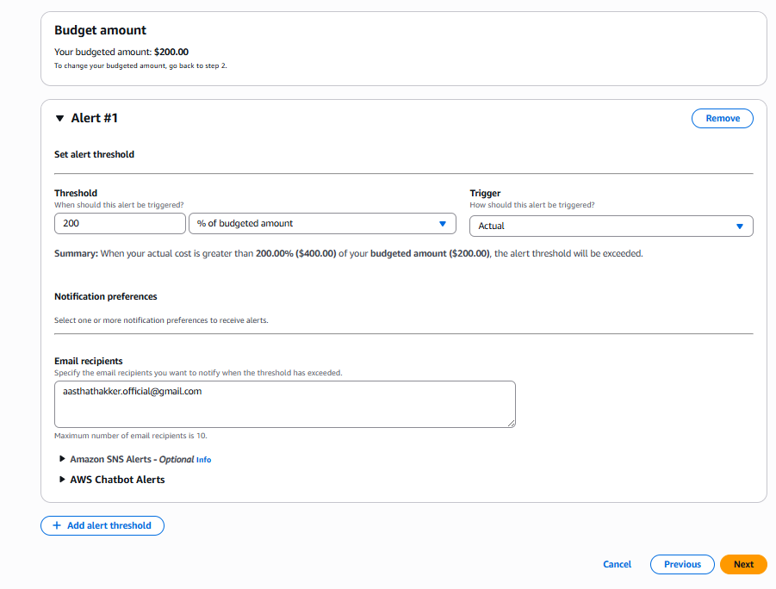
Reviewing budget configuration before creation.
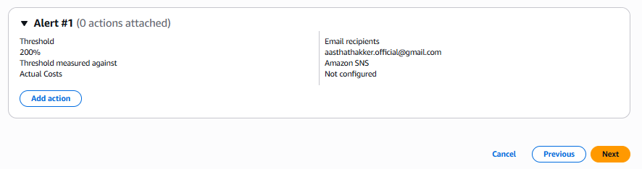
Budget notification settings.
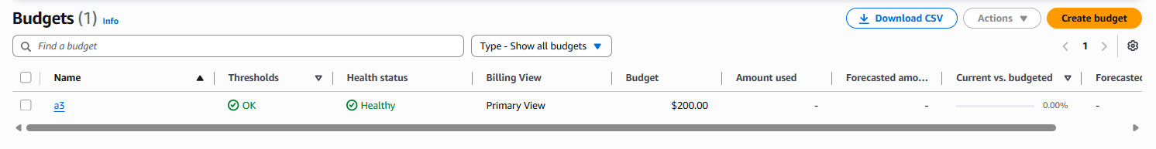
Budget 'a3' created successfully with a $200 threshold, status Healthy.

7.4 Storage Alarm - Usage > 100GB
CloudWatch's native EC2 metrics do not directly expose total EBS storage usage. Two approaches apply depending on requirement: (a) monitor EBS volume capacity directly for provisioned size, or (b) install the CloudWatch Agent on the instance to publish filesystem disk-usage metrics, then create a DiskUsage > 100GB alarm. This alerts before storage becomes a capacity problem.
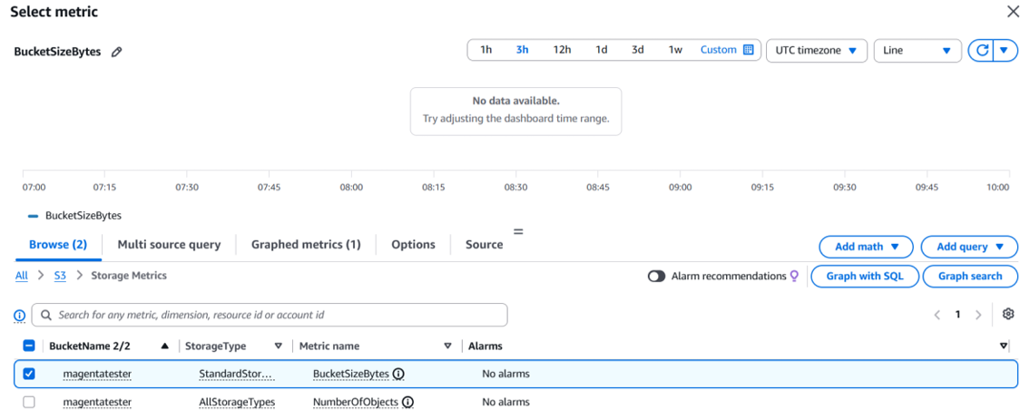
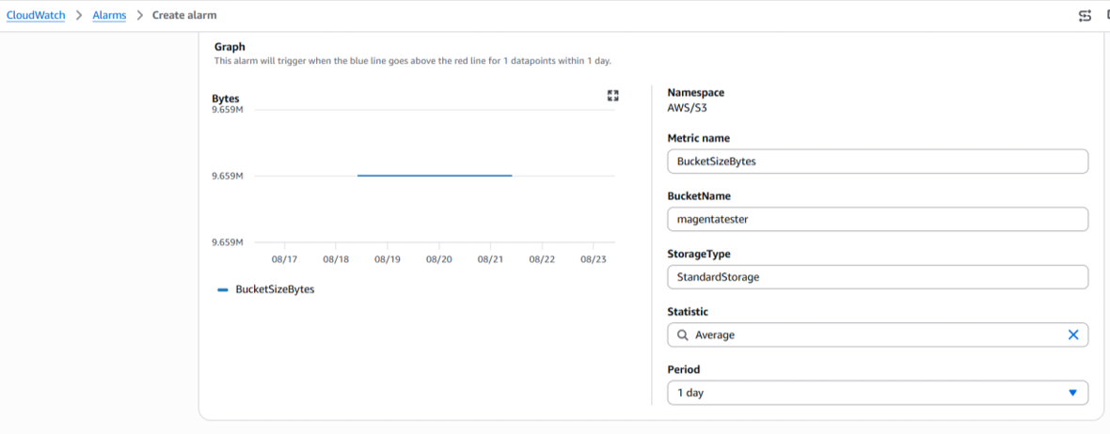
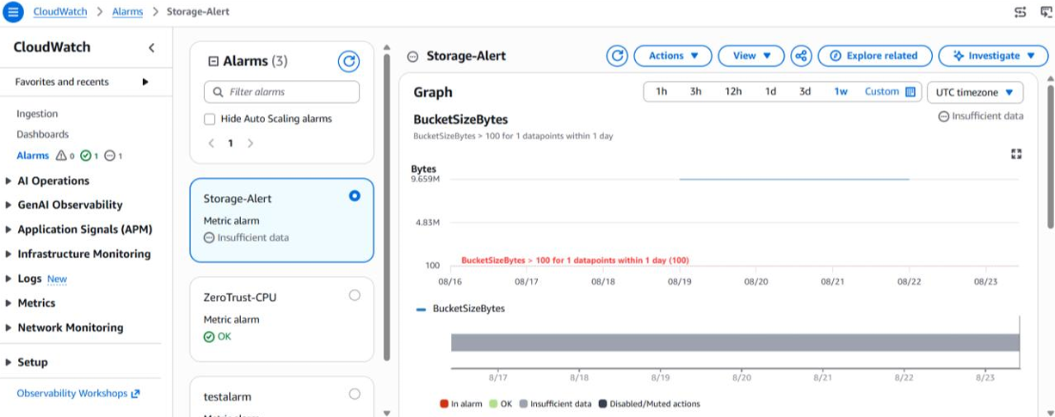

8. EventBridge Automation

8.1 Hourly EBS Snapshot
EventBridge → Rules → Create rule → Name: Hourly-EC2-Snapshot → Schedule: rate(1 hour), targeting the EBS volume attached to the EC2 instance via an automation action. This provides a recovery point if data is accidentally deleted or corrupted. For production use, AWS Backup is recommended over custom snapshot automation for scheduled backups.
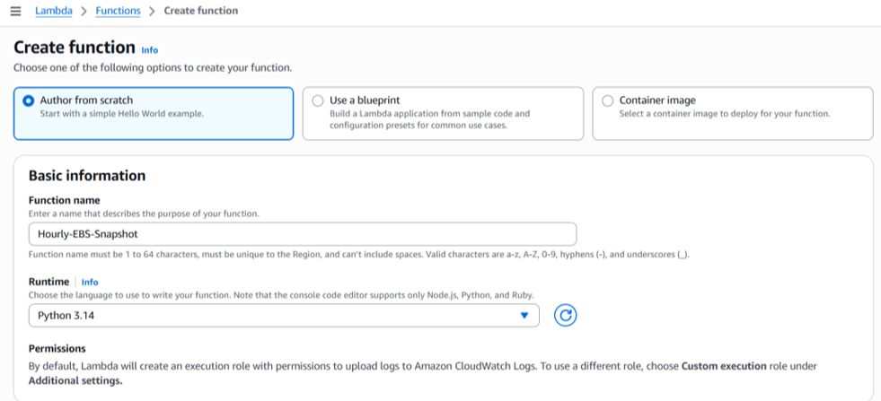
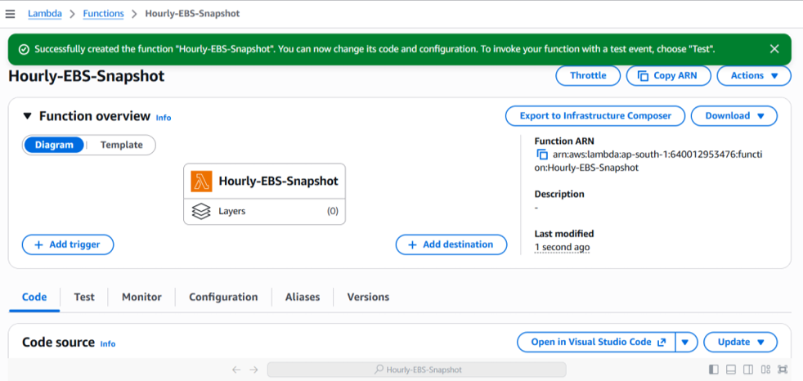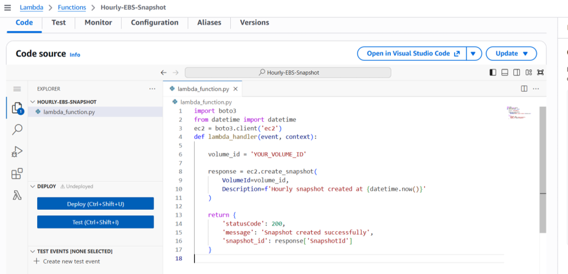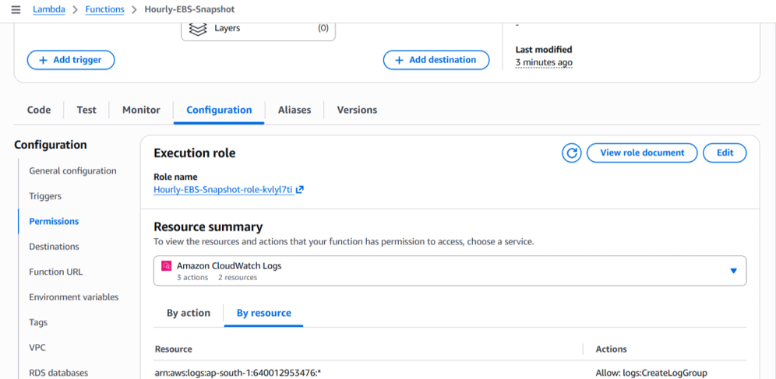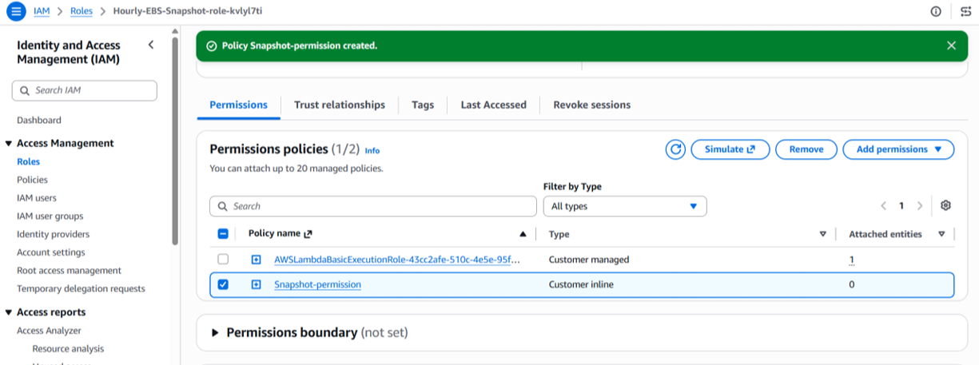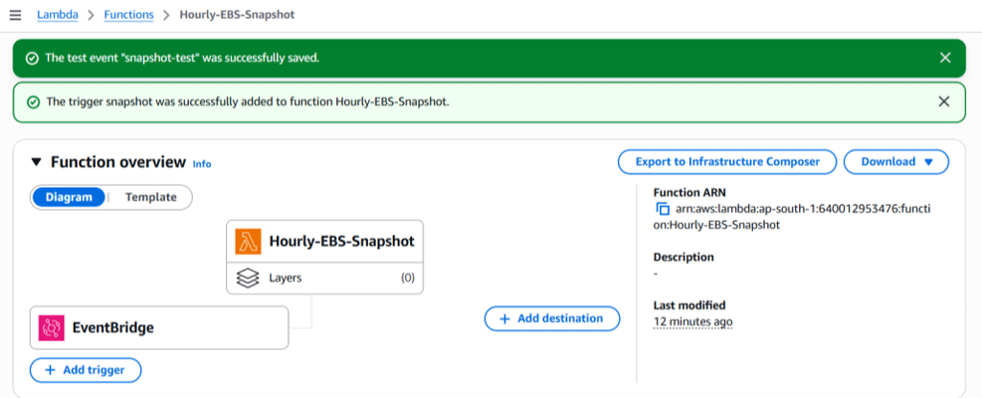
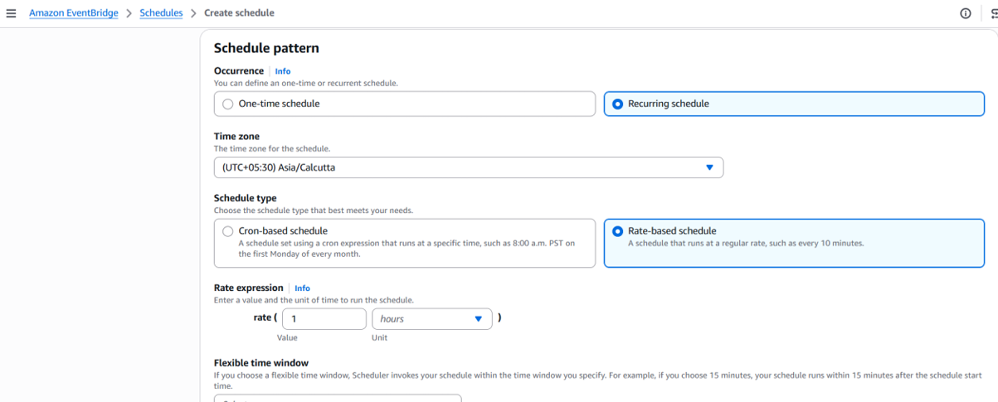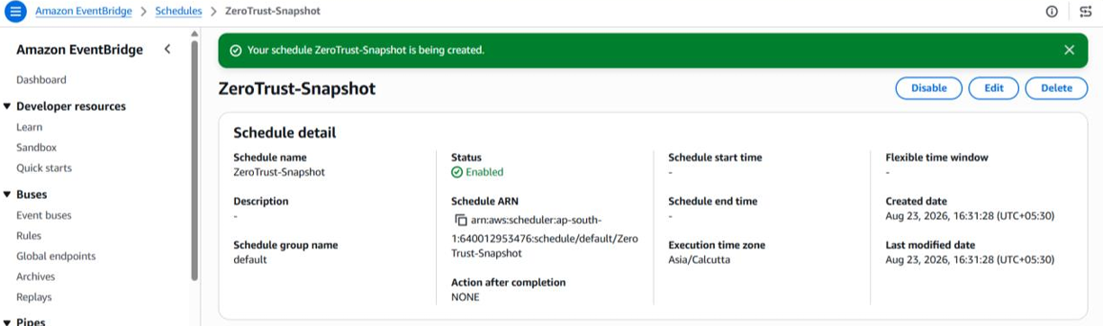
EventBridge rule event pattern configuration (EC2 EBS Volume Notification).

8.2 Sign-in Notification
An EventBridge rule was configured to detect AWS Console sign-in activity (via CloudTrail) and trigger a notification action, alerting on any user sign-in to the account.
